**Ready, Aim, Fire!!! – Trebuchet Launch**

**Worksheet**

* *Prepared by -*

**Declan Day, Anna Liu, Jana Mosko, Irving Zhang**

April 4th 2025

Your team’s goal is to derive the equations necessary to determine the mass of the counterweight box that would launch a **clay ball**. The most important components of the trebuchet are the swing arm, the counterweight box and the sling. We will assume that the sling behaves like a massless beam, therefore the massless sling rope doesn’t deform and remains fully extended throughout the entire throwing motion.

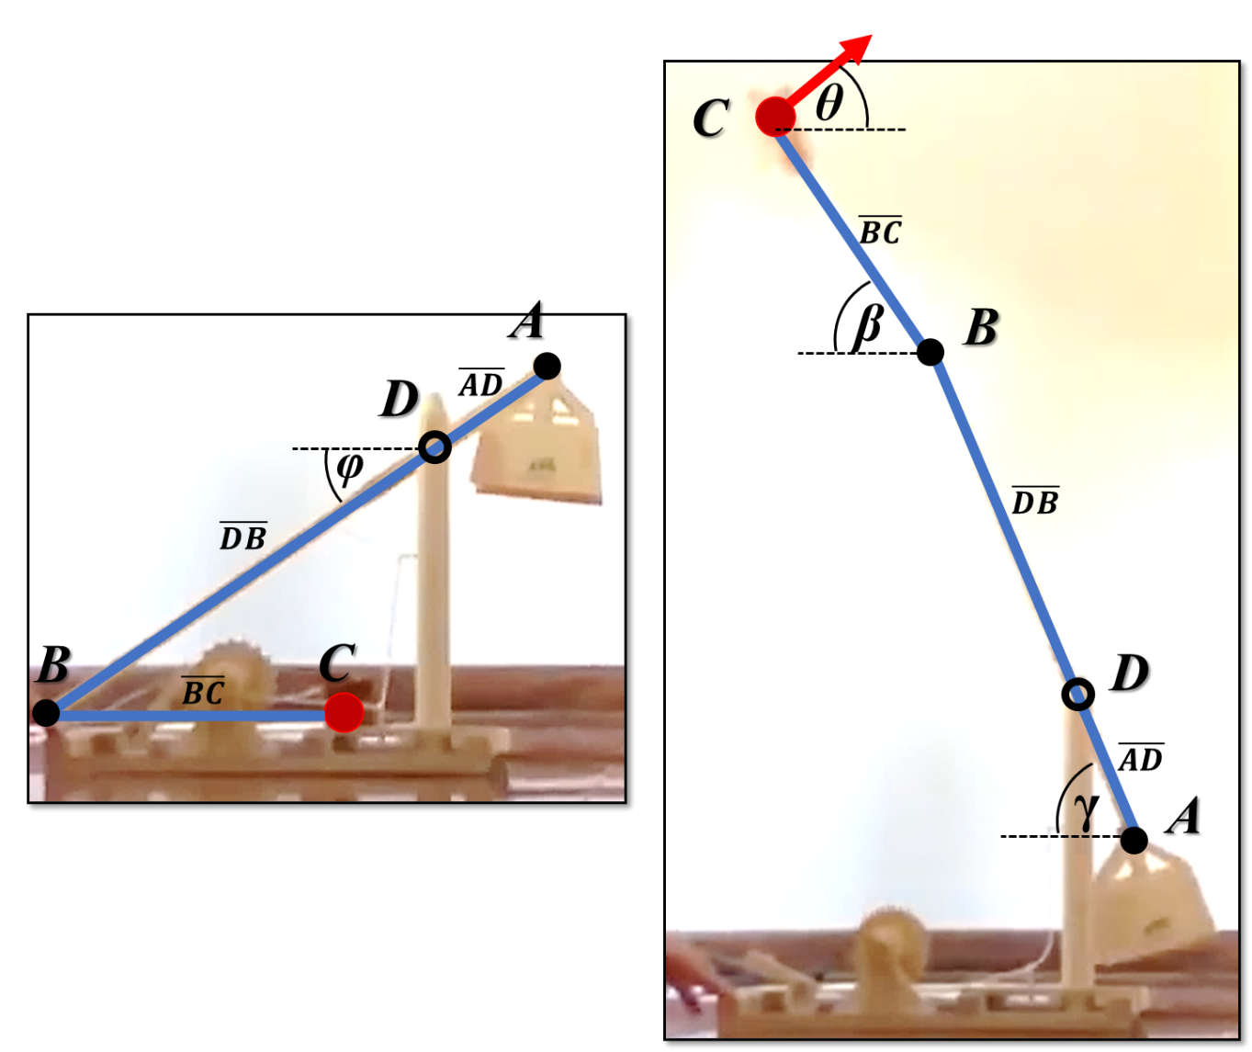

## Assumptions: List the assumptions that you make and be sure to explain why you chose those assumptions. For example, we assume that the sling arm is a massless rigid beam because as it swings around the axis of rotation the centripetal acceleration keeps the string tight, therefore it doesn’t really deform.

## The sling arm ADB is a massless rigid beam.

friction is negligible, because in such a small system and in such a short time what friction there is cannot affect the values enough to factor into the equations.

The final state is when the counterweight hits the ground because it cannot provide any more potential energy to the system.

The ground is considered to have zero potential energy.

**Label Definition:**

Swing arm BC:

Sling arm ADB:

Clayball/Sphere:

Counterweight: where M is the mass of the counterweight we need to find, 32g is the mass of the box.

## Work-Energy Approach

First, let us consider a Work-Energy approach to the problem. Draw the initial and final positions. Identify the important points of interest on your drawing and their respective heights. Show velocity vectors too.

**Initial Position**

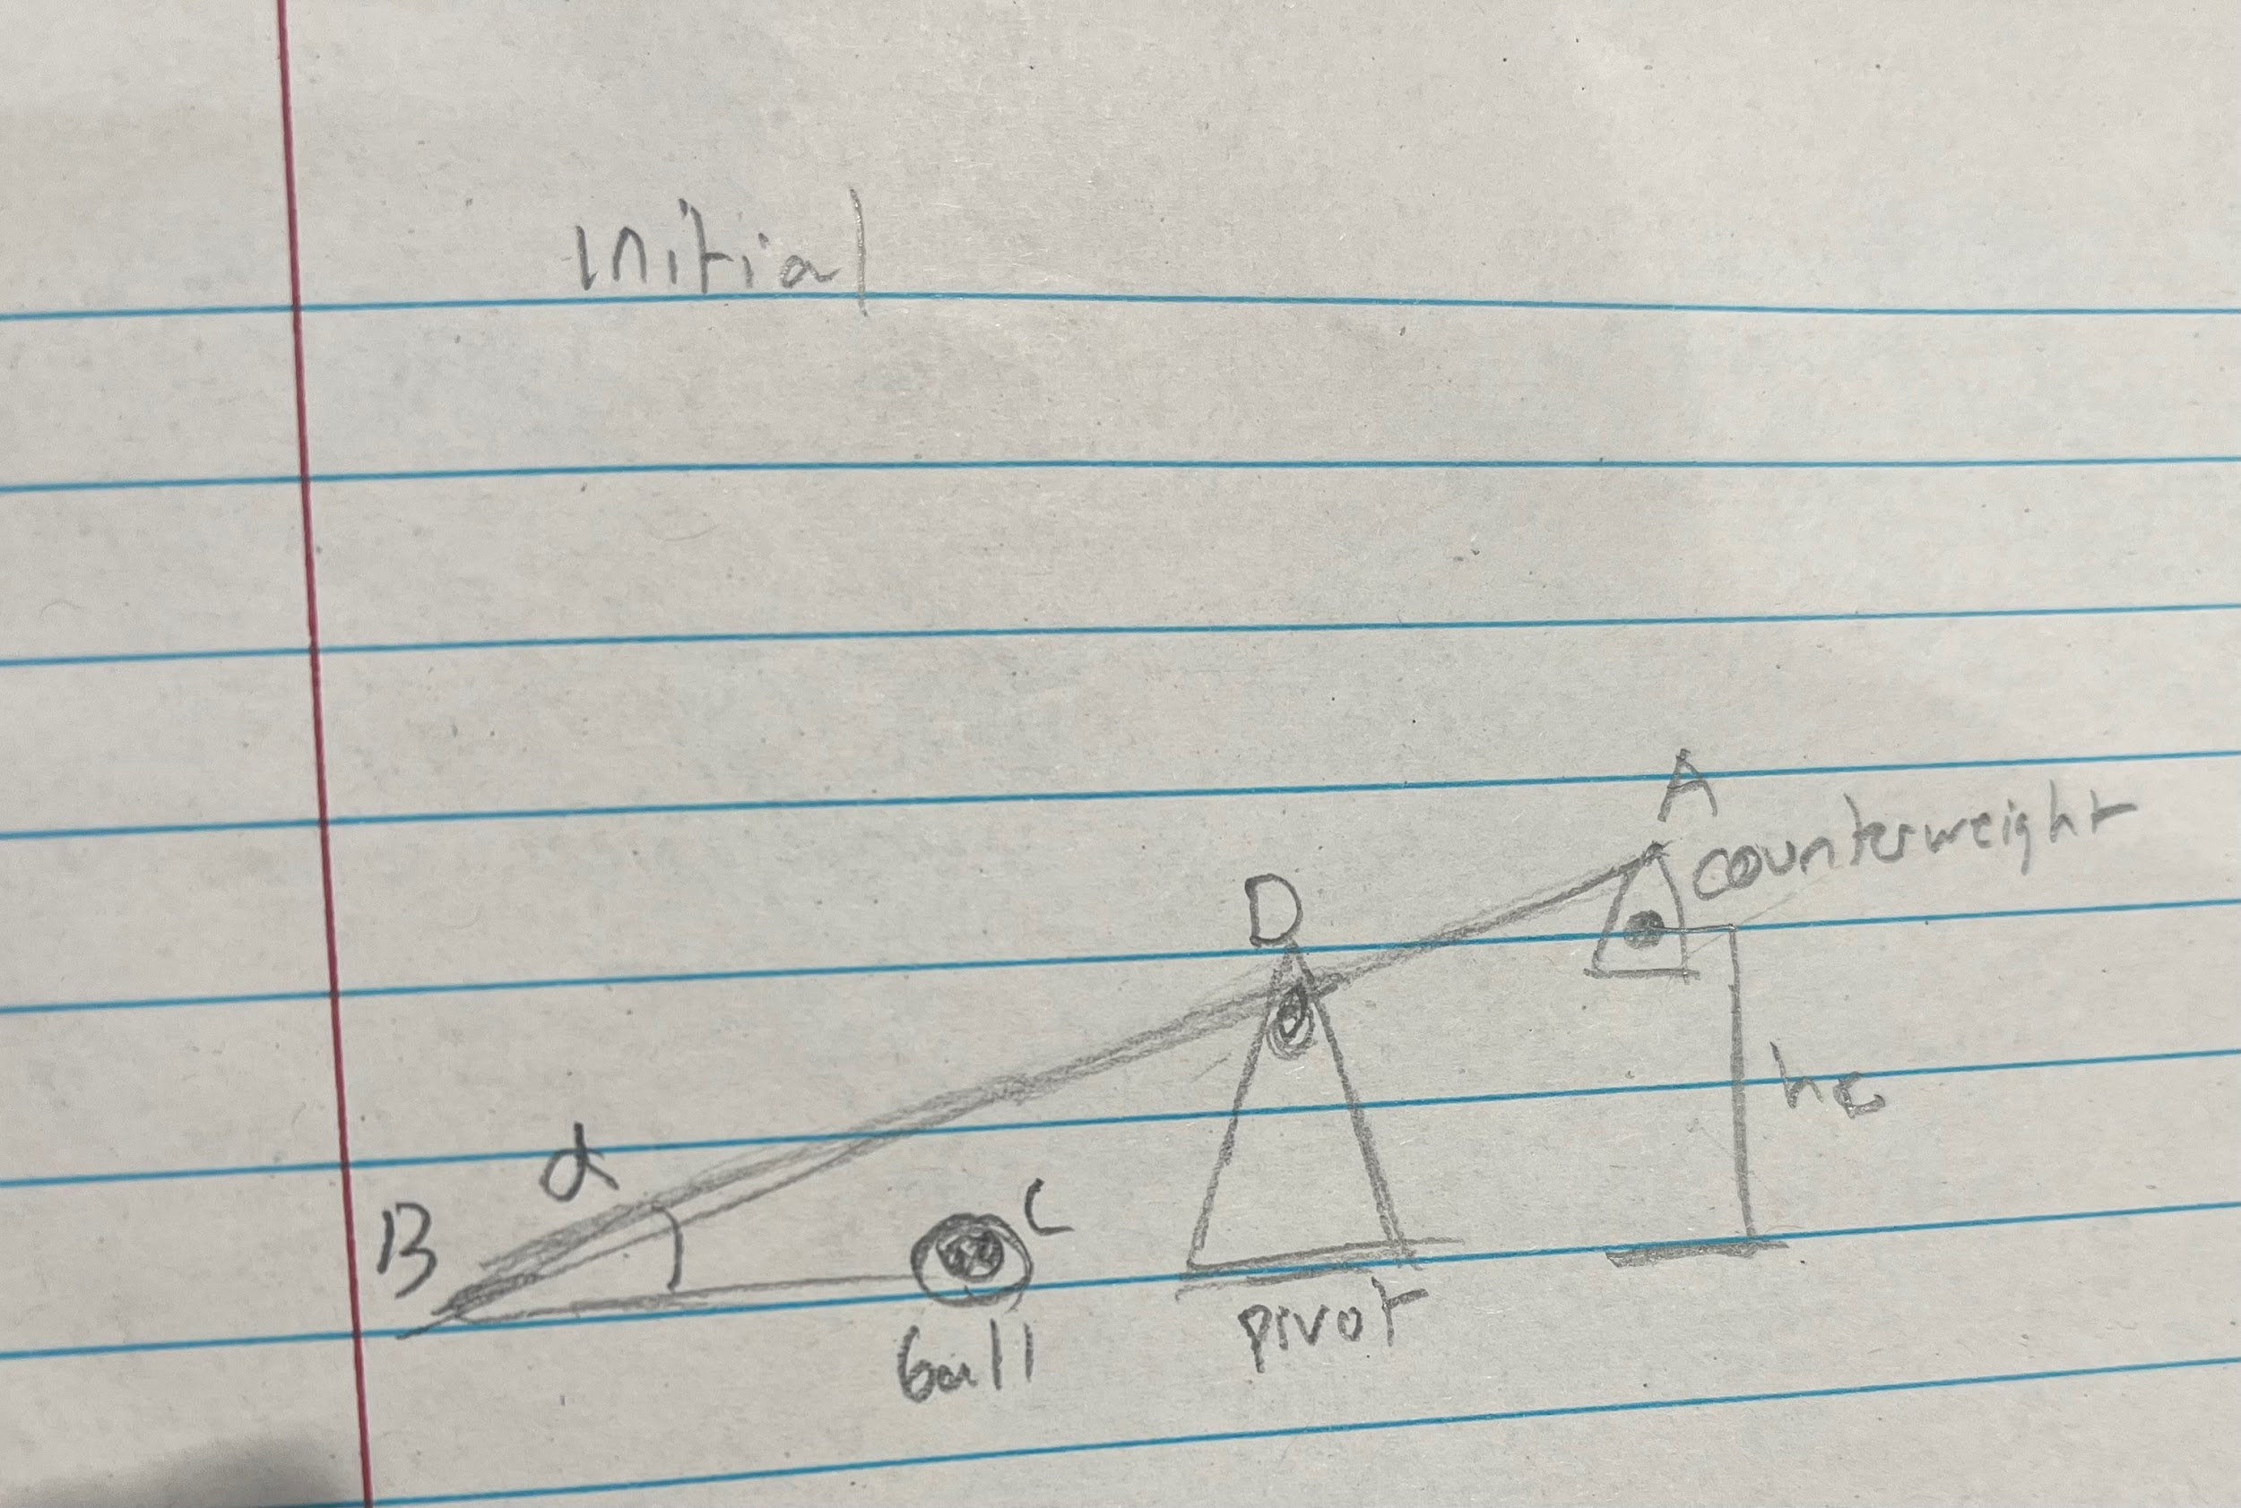

**Final Position**

## 

## 1) Work-Energy Approach

Next, let us consider the equations needed for the Work-Energy approach. Be sure to consider: if the body is in translation and/or rotation, the velocities of the *COM*s, and the mass moment of inertia for each body.

1. The initial and final height of the *COM* ( ) for each rigid bodyA black and white circle with a cross

   Description automatically generated
2. If each body is in translation and/or rotation
3. If the axis of rotation is located at the *COM* for each body
4. The mass moment of inertia for each body
5. Consider the work due to non-conservative forces =0

**List Work-Energy Equations Below:**

The counterweight is in pure clockwise rotation by beam AD, the axis of rotation is not on the body but the point D.

The clay ball is in translation and clockwise rotation by beam BC, and the axis of rotation is not on the COM of the body but on point B.

## 2) FBD = KD: Newton’s 2nd Law Approach

Let’s evaluate the counterweight box, swing arm, and sling. For this approach we are going to evaluate the rigid bodies at the snapshot in time when the ball is being released. The first thing we need to do is draw the FBD and KD for each rigid body.

1. Draw the approximate location of the *COM*
2. FBD: Draw the forces and moments acting at the locations of interest on the FBD
3. KD: Draw the accelerations () acting on the body

**FBD = KD → Counterweight Box**

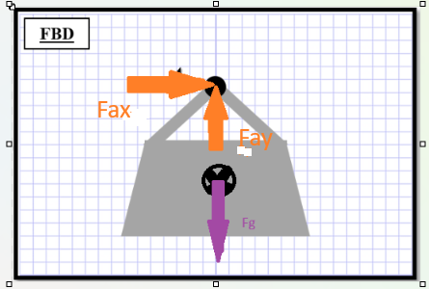

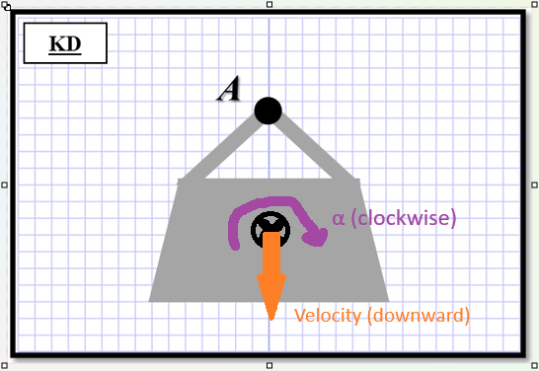

**FBD = KD → Swing Arm**

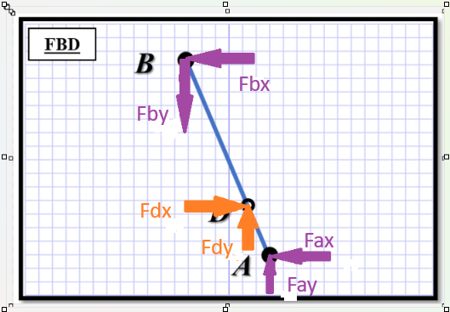

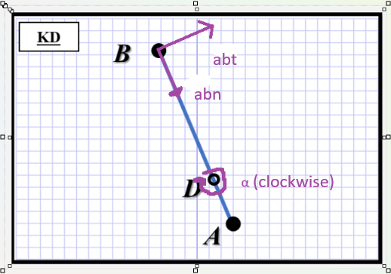

**FBD = KD → Sling Arm**

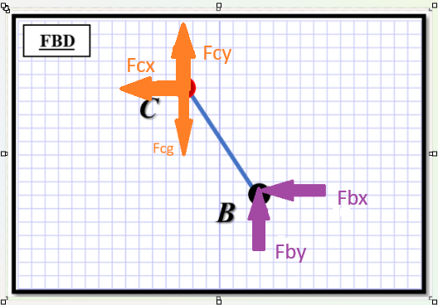

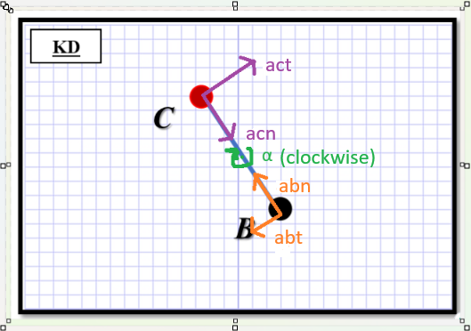

## 2) FBD = KD: Newton’s 2nd Law Approach

Next, let us consider the equations needed for the Work-Energy approach. Be sure to consider: if the body is in translation and/or rotation, the velocities of the *COM*s, and the mass moment of inertia for each body. For each rigid body, you will want to consider which of the following equations you need:

1. Kinematic motion
2. Rotation about a fixed axis
3. General Planar motion (translation & rotation)
4. Relative velocity
5. Relative acceleration

**List Newton’s 2nd Law Equations Below:**

**Counterweight Box:**

**List Newton’s 2nd Law Equations Below:**

**Sling Arm ABD(massless):**

**List Newton’s 2nd Law Equations Below:**

**Swing beam:**